**PYTHON LABORATORY**

**Exercise No:14**

**Date:22/11/2020**

**Aim:**

Write a Python class to find validity of a string of parentheses, '(', ')', '{', '}', '[' and '].

**Program:**

def areBracketsBalanced(expr):

stack=[]

Expressions=["(","{","["]

for c in range(len(expr)):

if (expr[c] in Expressions):

stack.append(expr[c])

else:

if not stack:

return False

current__c = stack.pop()

if (current__c =="(" and expr[c]!=")"):

return False

if (current__c == "{" and expr[c]!="}"):

return False

if (current__c == "[" and expr[c]!="]"):

return False

if stack:

return False

else:

return True

if __name__ =="__main__":

expr = input()

if (areBracketsBalanced(expr)):

print("Output: Valid")

else:

print("Output: Invalid")

**Output:**

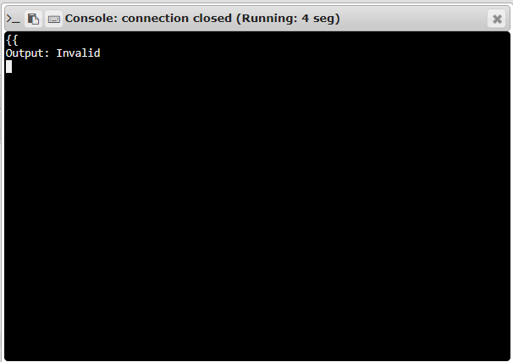

**Link:**

[**http://103.53.53.18/mod/vpl/forms/edit.php?id=327&userid=1708#**](http://103.53.53.18/mod/vpl/forms/edit.php?id=327&userid=1708)

**RESULT:**

The validity of a string of parentheses is successfully verified.